Press Release
ROBIN Horizon Europe project has officially kicked off!
Thessaloniki, September 29, 2022 – Bioeconomy has the potential to substantially contribute to the objectives of the European Green Deal while at the same time Europe’s regional authorities have a crucial role to play as agents of inclusive and resilient economic development for their territories. How can Europe’s regional authorities explore their potential for bioeconomy governance schemes so they could contribute to the mission of the European Union for a faster green transition?
On the 26th and 27th of September 2022, the ROBIN partners met in Thessaloniki in Greece to officially kick start the project and discuss the next steps for its successful deployment! With Q-PLAN coordinating this Horizon Europe project, ROBIN – “Deploying circular BIOeconomies at the Regional level with a territorial approach” (Grant Agreement no: 101060504) has set the stage to empower and fulfill the role of European regional authorities to use social innovative techniques and shape their governance structures within the frame of circular bioeconomy.
13 partners from 5 European countries will set up Multi-Actor Regional Constellations in 5 pilot regions: the region of Central Macedonia in Greece, the region of Zilina in Slovakia, the Southern Region of Ireland, the region of Andalusia in Spain, and Baden-Württemberg in Germany. In these regions, they will co-create novel governance structures and deploy circular bioeconomy strategies. ROBIN will provide a practical toolbox to the regions so as to improve the operation and monitoring of their future bioeconomy models. Also, it will provide them with tailored support for enhanced stakeholder engagement in collaboration with the Circular Cities and Regions Initiative (CCRI-CSO).
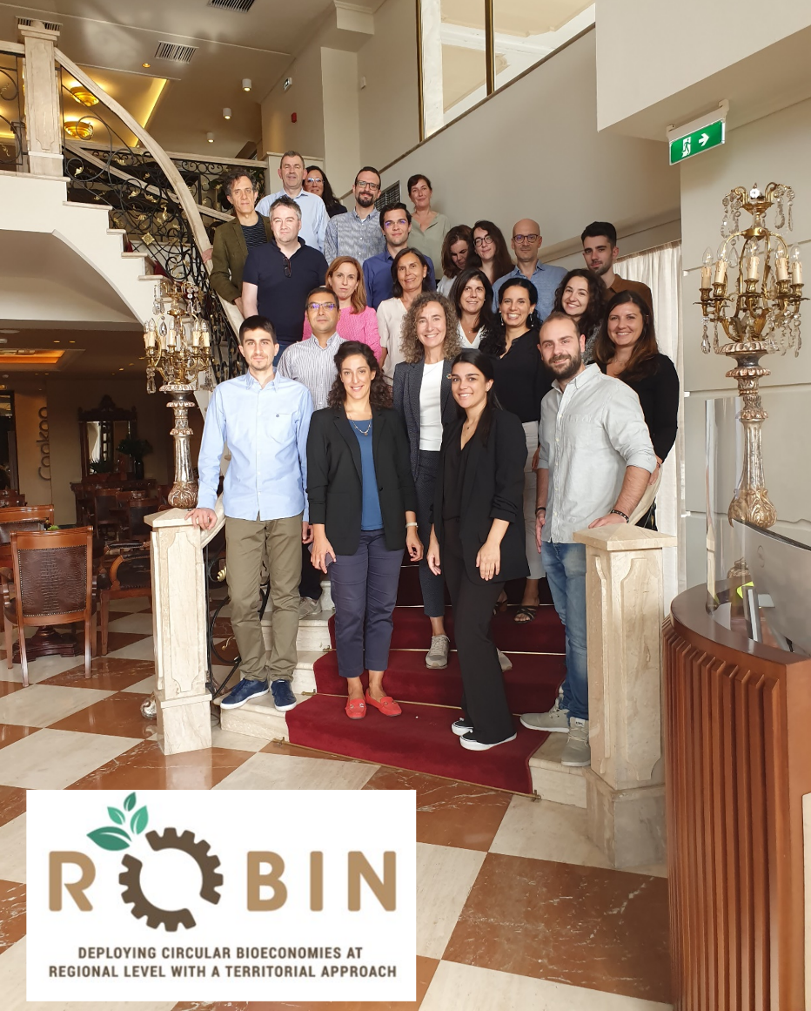

Stay tuned to learn more about ROBIN and its future activities!
13 partners:
- Q-PLAN INTERNATIONAL ADVISORS PC (Coordinator)
- FUNDACION CORPORACION TECNOLOGICA DE ANDALUCIA
- WHITE RESEARCH SRL
- PEDAL CONSULTING SRO
- STEINBEIS 2I GMBH
- ROZVOJOVA AGENTURA ZILINSKEHO SAMOSPRAVNEHO KRAJA NO
- MUNSTER TECHNOLOGICAL UNIVERSITY
- ARISTOTELIO PANEPISTIMIO THESSALONIKIS
- REGION OF CENTRAL MACEDONIA
- CONSEJERÍA DE AGRICULTURA, PESCA, AGUA Y DESARROLLO RURAL
- INSTITUTO ANDALUZ DE INVESTIGACIÓN Y FORMACIÓN AGRARIA, PESQUERA, ALIMENTARIA Y DE LA PRODUCCIÓN ECOLÓGICA
- BIOPRO BADEN-WUERTTEMBERG GMBH
- SOUTHERN REGIONAL ASSEMBLY

